□ PARADISE HOTEL BUSAN  ■ RESERVATION REQUEST |  | 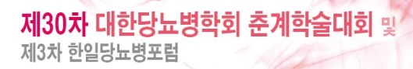 |  |  |  |  |   
Check In : |  |  |  | Check out: |  |  | Remarks
Room Type: |  |  |  | Room Rate: |  |  |   □ C/I, C/O Time Inform  □ Transportation or  Restaurant RSVN
No. of Persons:
□ Smoking  □ Non-smoking | Guest Name: □ Mr. □ Ms.  Last Name:  First Name:
Address:
Tel. No. |  |  | Email:
 |  |  | Fax:
PAYMENT
Credit Card Type: □ Visa □ Masters |  |  |  |  | Expiry Date:
Credit Card Holder:
Booked by: |  |  |  |  | Tel no.
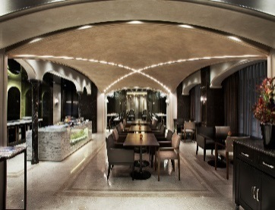
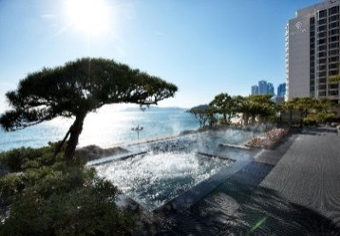
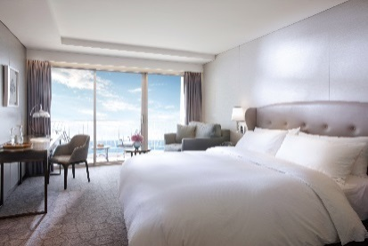
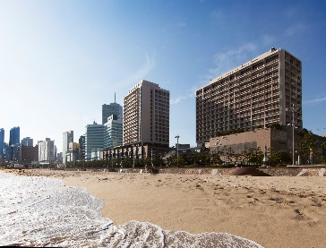
Rooms Category |  |  |  |  | Special Room Rate Only |  | Breakfast Rate Only
Deluxe City View Room  Special Rate |  |  |  |  | □ KRW 180,000 |  | □ KRW 25,000/ Person
Deluxe Ocean Side View Room  Special Rate(Double BedType Only) |  |  |  |  | □ KRW 220,000 |  | □ KRW 25,000/ Person
Deluxe Ocean Terrace View Room Special Rate |  |  |  |  | □ KRW 230,000 |  | □ KRW 25,000/ Person
* The rates above are the special rate only for Conference attendees.
* The rates above are non-commissionable, and they are exclusive of 10% Service Charge and 10% Government Tax.
* Full Buffet breakfast will be served at the Escoffier on the Lobby Floor.
* Transportation can be get inform on Lobby floor by Concierge.
General Benefits  - 50% Special discount on admission to the sauna  - 50% Special discount on admission to Ocean Spa(CIMER)  - Free access to fitness center and swimming pool  - Two complimentary bottles of mineral water in the room  - Special bath amenity - L’OCCITANE  - Free Internet access & Wi-Fi |  |  |  |  |  | Cancellation Policies:  - Cancellation or No Show after the room reservation is being charged as below;  - From the agreement date to 7days prior to Arrival date : 30% of the Room charge  - From 7days to 3days prior to Arrival date : 50% of the Room charge  - From 2days or less prior to Arrival date : no refund
Please send reservation to: res@paradisehotel.co.kr or call Tel no. +82 51 749 2111~3

